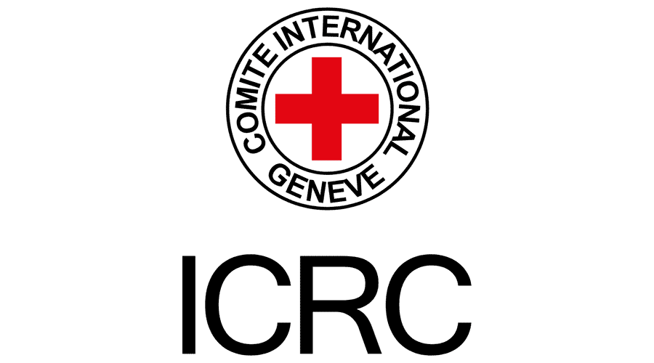 | 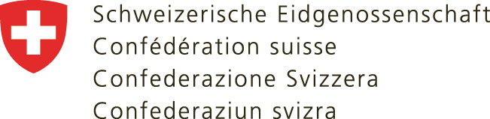  Swiss Embassy in Poland | 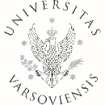 | 

75th anniversary of the Geneva Conventions - universal consensus on the need to preserve humanity in war and the impact of harmful information on people protected by international humanitarian law (IHL)

University of Warsaw
Aula Baszkiewicza, Krakowskie Przedmieście 26/28
11 October 2024
09:00 – 10:00 Opening of the exhibition Dialogues on Humanity.
Speeches by guest(s) of honor

10:00 – 11:00 Panel I: 75th anniversary of the Geneva Conventions - universal consensus on the need to preserve humanity in war
Moderator: Dr Elżbieta Mikos-Skuza, University of Warsaw
- Dr Nele Verlinden, Preserving humanity in war by respecting the protective purpose of International Humanitarian Law, ICRC, Legal Advisor.
- Dr Magdalena Stefańska, The role of internal and external communication in humanitarian aid operations – case study of the Polish Red Cross response to Ukraine and impacted countries operation, Polish Red Cross, Head of International Relations Department.
- One speaker more – to be confirmed
- Q & A Session
11:00 – 11:15 Break
11:15 – 12:15 Panel II: The impact of harmful information on people protected by IHL
Moderator: Dr Nele Verlinden, ICRC
- Prof. dr hab. Jacek Czaputowicz, Importance of the Geneva Conventions in the Polish foreign policy, Faculty of Political Science and International Studies of the University of Warsaw, Chair of European Union Policies
- Prof. dr hab. Marcin Marcinko, Information Warfare as a Challenge to International Humanitarian Law, Jagiellonian University in Kraków, Faculty of Law and Administration, Chair of Public International Law.
- Dr Mateusz Piątkowski, Social Media and Disinformation: the Tough Moment for the IHL, University of Łódź, Faculty of Law and Administration, Chair of International Law and International Relations.
- Dr Elżbieta Mikos-Skuza, Role of Fact-Finding and Monitoring in Armed Conflicts in times of Disinformation and Fake News, University of Warsaw, Faculty of Law and Administration, Head of Studies in Humanitarian Action.

12:15 Award ceremony of the national student essay competition “Disinformation and hate speech during armed conflict: what is their impact on people protected by international humanitarian law?”

12:30 Cocktail

